Universal Single-Use Bronchoscope Tracker
Fabrication Blueprint for Build Hand-off
Revision v4-FAB · derived from Engineering Plan v4 · June 30, 2026
NONCLINICAL SIMULATION PROTOTYPE — TRAINING / EDUCATION / BENCH VALIDATION ONLY. NOT A MEDICAL DEVICE. NO SCOPE MODIFICATION.
This document translates the v4 engineering plan into a build package a maker, machinist, or PCB assembler can fabricate. It commits the v4 design parameters to baseline dimensions, lists every physical part with quantity and specification, defines tolerances and print settings, and gives the assembly order. Where a value depends on the specific scope or must be confirmed on the bench, it is flagged rather than hidden.

Contents
0. How to use this blueprint 2
1. System overview 2
2. Baseline scope family and scope-specific datums 3
3. Module A — lever module 4
4. Module B — cord tracker 6
5. Interconnect cable 9
6. Wiring and pin map 10
7. Consolidated bill of materials 11
8. Print settings, materials, and tolerances 12
9. Assembly sequence 13
10. Build these de-risking jigs first 14
11. Open build decisions 14
12. Builder hand-off checklist 15

0. How to use this blueprint
Every dimension in this document carries one of three labels. Treat them differently:
Label | Meaning
FIXED | Driven by a purchased component or by physics. Do not change without changing the part.
BASELINE | A committed starting value chosen from the v4 ranges. Build to this, then tune during Phase 0 bench testing if the validation data calls for it.
MEASURE | Scope-specific. Must be measured on the actual target bronchoscope before the affected part is printed.

Conventions. All linear dimensions are millimetres unless noted. All threaded hardware is metric. “Cord” means the scope insertion tube; “handle” means the operator's handpiece. The cord-axis convention used in the drawings is: insertion is +X, the optical sensor looks up at the cord from below, and the compliant cap presses down from above.
In scope for the builder: all printed parts, fasteners and mechanical hardware, mounting of the electronic modules, the interconnect cable, the net-level wiring, print settings, tolerances, and assembly order.
Out of scope here (supplied separately): PCB gerbers and firmware source live in the project repository; the final validated scope-specific adapter dimensions are produced per-model during validation. This blueprint builds the first working unit on the baseline scope family.
Safety guardrails (non-negotiable): training/simulation use only; nothing adheres to, drills, or disassembles the scope; the device never touches or impedes the real suction or working-channel controls.

1. System overview
Two clip-on modules turn an unmodified disposable bronchoscope into a 3-degree-of-freedom simulator input device. Module A reads thumb-lever flexion; Module B reads insertion depth and roll at the cord. All sensing is wired and fused in one firmware loop on Module B, which presents to the host as a single USB HID gamepad (with a CDC serial channel for calibration). The link between modules is differential I²C over a 1.2 m cable, with a PCA9615 transceiver at each end.
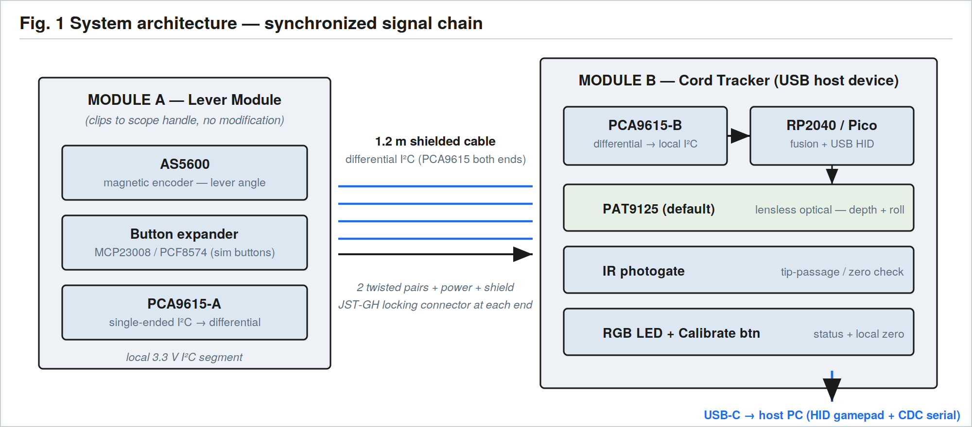
Fig. 1 — The two modules, the differential-I²C interconnect, and the single synchronized USB report.
What the builder delivers: two assembled, cabled modules plus a desk stand, built on the baseline scope family, that enumerate as one USB gamepad and pass the Phase 0 bench checks (depth, roll, friction, cable stability).

2. Baseline scope family and scope-specific datums
v1 is built and validated on a single disposable bronchoscope family. The baseline assumes a Regular-class disposable with a 5.0 mm insertion-tube outer diameter. Only two parts are scope-parametric — the Module A clamp jaws and the Module B V-groove insert cassette. Everything else is fixed across scopes. Before printing those two parts, measure the datums below on the actual target scope.
Datum (MEASURE) | Why it matters | Baseline assumption | How to measure
Handle clamp section (W × H or Ø) | Sets clamp jaw opening and pad thickness | ~25–35 mm grip section | Callipers across the handle neck where the clamp will sit
Thumb-lever throw (neutral / full-up / full-down) | Sets follower-arm length and sweep; defines calibration end-stops | Arm ≈ 35 mm reaches full travel | Mark lever at each extreme; record angular throw and linear tip travel
Lever contact-face width | Sets roller / shoe width | 6–8 mm shoe | Callipers across the lever pad
Insertion-tube OD | Sets wiper ID, V-groove, channel clearance | 5.0 mm | Callipers at several points along the cord
Handle face → clamp datum | Repeatable clamp placement | Hard datum shelf on upper jaw | Pick a fixed handle feature as the registration reference

Do not claim universality until each additional scope family has its own measured clamp, insert cassette, and calibration profile.

3. Module A — lever module
A printed two-jaw clamp grips the handle without modifying it and carries a pivoted follower arm. The arm's hub holds a diametric magnet coaxial with the pivot, sitting at a controlled airgap over an AS5600 magnetic encoder; the arm's tip rides the thumb lever on a roller or polished shoe under light spring preload. The clamp body also houses the cable transceiver and optional simulator buttons.
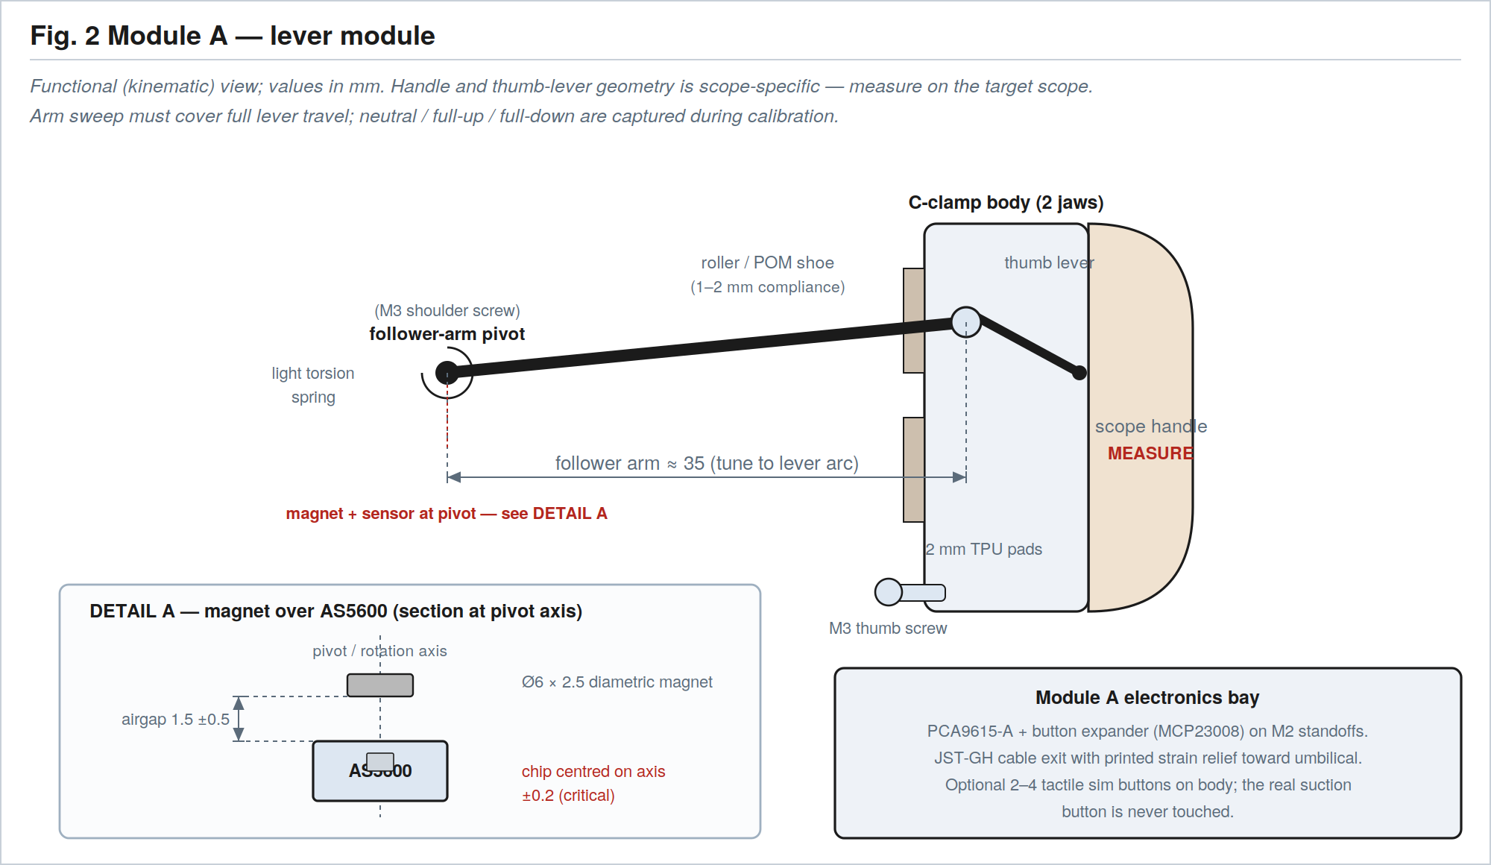
Fig. 2 — Module A kinematics, with DETAIL A showing the magnet-over-AS5600 section at the pivot axis.

3.1 Module A — printed parts
Part | Qty | Material | Key dimensions (mm) | Notes
Clamp jaw – upper | 1 | PETG/ASA | Grip section per MEASURE; hard datum shelf; 2 dowel bores Ø3.0 | Parametric to the scope handle
Clamp jaw – lower | 1 | PETG/ASA | Matching grip; M3 insert boss for thumb screw | Parametric to the scope handle
Follower arm | 1 | PETG/ASA (100% infill) | Pivot-to-contact ≈ 35; Ø3.0 pivot bore | Print flat for strength along length
Magnet hub | 1 | PETG/ASA | Magnet pocket Ø6.0 (−0.05) × 2.6 deep; coaxial with pivot | May be integral to follower arm
Roller carrier / shoe | 1 | POM or PETG + TPU pad | Shoe face 6–8 wide; 1–2 compliance | Roller option: 6×2.5 bearing on press pin
AS5600 bracket | 1 | PETG/ASA | Chip centred under pivot axis; 0.5 shim feature for airgap | 2× M2 inserts to breakout holes
Electronics bay + cover | 1 + 1 | PETG/ASA | Bay for PCA9615-A + expander; JST-GH exit + strain-relief saddle | Cover clips or M2 screws
Button caps (optional) | 2–4 | TPU/PETG | Fit 6×6 mm tactile switch | Only if sim buttons fitted

3.2 Module A — hardware
Item | Qty | Specification | Notes / example source
Heat-set inserts, M3 | 1–2 | Brass, ~4.0 mm hole | Thumb-screw boss (CNC Kitchen / McMaster)
Heat-set inserts, M2 | 4–6 | Brass, ~3.2 mm hole | AS5600 bracket, electronics bay
Thumb screw, M3 | 1 | M3 × 16, knurled, captive | Clamp clamping force
Shoulder screw | 1 | M3 thread, Ø3.0 × 12 shoulder | Follower-arm pivot (or Ø3 dowel + E-clip)
Torsion spring | 1 | ~0.4 mm music wire, light (5–15 mN·m) | Keeps roller on the lever through travel
Diametric magnet | 1 | Ø6 × 2.5, diametrically magnetised | FIXED to AS5600 — do not substitute axial
Roller bearing (option) | 1 | Ø6 OD × Ø2.5 ID | If roller, not shoe
TPU/silicone pads | 2 | 2 mm, Shore ~70A | Clamp jaw faces (grip + scope protection)
Dowel pins | 2 | Ø3.0 × ~10 steel | Jaw alignment
Cable connector | 1 | JST-GH 6-pin + crimp contacts | Detachable strain-resistant cable

3.3 Sensor and calibration (FIXED geometry)
- AS5600 magnetic rotary encoder reads the follower-arm angle, which maps to the thumb-lever angle.
- Magnet Ø6 × 2.5 diametric, press-fit into the hub, airgap 1.5 ±0.5 mm to the chip face (AS5600 tolerates 0.5–3 mm).
- Magnet axis must be the rotation axis and centred on the chip within ±0.2 mm (critical); keep hub runout < 0.2 mm.
- Calibration captures neutral, full-up, full-down, and an optional midpoint to detect shoe slippage or clamp misplacement.

3.4 Module A electronics mounting
PCA9615-A (single-ended ↔ differential I²C) and the button expander (MCP23008/PCF8574) mount in the bay on M2 standoffs/inserts and share the local 3.3 V I²C segment with the AS5600. The JST-GH connector exits through a printed strain-relief saddle aimed along the scope umbilical path. Add TVS/ESD protection on the cable lines.

4. Module B — cord tracker
Module B is the critical module: a split clamshell whose internal cord channel passes through four zones in a fixed order — wiper, photogate/zero, tracking (V-groove + optical), and the mounting flange. A sealed electronics bay sits behind/below the channel.
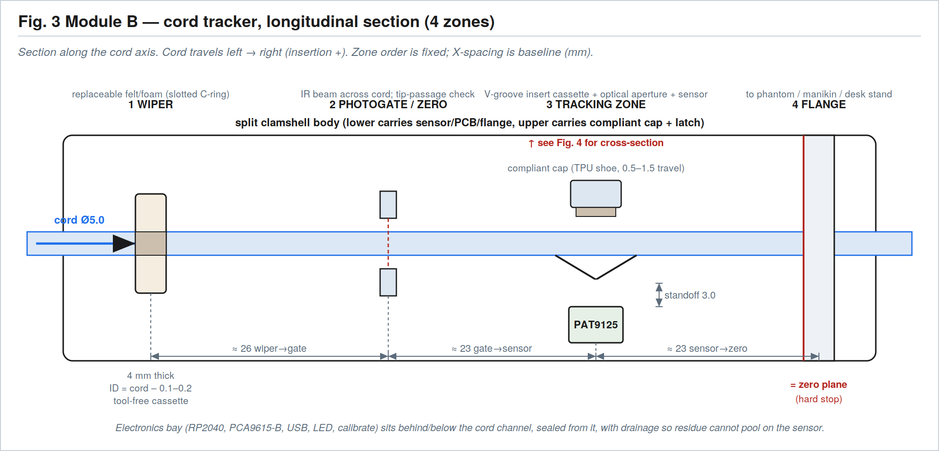
Fig. 3 — Longitudinal section: the four zones in order along the cord, with baseline X-spacing.

4.1 Clamshell body
- Two-piece body, fully separable (baseline), located by 2× Ø3.0 dowel pins and closed by a captive M3 thumb screw (or printed over-center latch).
- Approximate envelope 95 × 48 × 40 mm (BASELINE) — refine after Pico/PCB placement.
- Cord-channel centerline held at a fixed height over the sensor; electronics bay sealed from the channel with a drain/removable cover so residue cannot pool on the sensor.
- Material PETG/ASA; the optical-zone insert surface in POM/PTFE or polished resin if friction is high.

4.2 Zone 1 — wiper cassette (replaceable)
A tool-free cassette drops in transverse to the cord and holds a slotted C-shaped felt/foam ring so it can be swapped without threading over the distal tip. It sits upstream of the photogate and sensor.
Parameter | Baseline value
Ring inner diameter | cord OD − 0.1–0.2 → 4.8–4.9 (for 5.0 cord); tune by material
Ring thickness (along cord) | 4 mm (range 3–5)
C-slot width | ~1.5 mm (less than cord OD so the ring wraps)
Material | Felt or high-density foam
Retention | Detent/click; spares stored in the kit
Firmware reminder | Replace after N sessions or when SQUAL falls

4.3 Zone 2 — photogate / zero
- IR slotted optical interrupter (slot ~3–5 mm) positioned so the cord/tip breaks the beam across the channel at a defined gate plane (±0.3 mm).
- Captured in a printed pocket; leads route to the main PCB. Manual zero at the flange plane remains available in firmware.

4.4 Zone 3 — tracking zone (the critical optics)
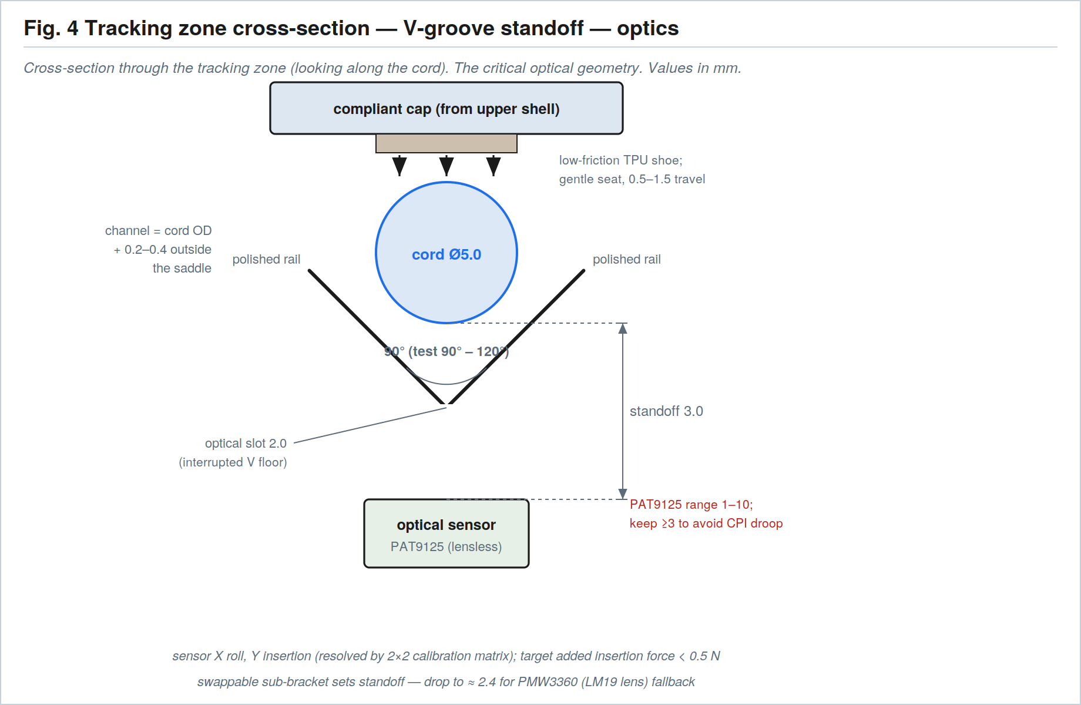
Fig. 4 — Tracking-zone cross-section: V-groove standoff, interrupted optical slot, and sensor distance.

V-groove insert cassette (scope-parametric)
Parameter | Baseline value
V-groove included angle | 90° (BASELINE; bench-test 90° and 120°)
Optical slot width | 2.0 mm (range 1.5–2.5, sensor-dependent); slot length ~3–4 along cord
V floor at aperture | Interrupted (open) so the sensor sees the cord directly — never an opaque floor
Channel clearance outside saddle | cord OD + 0.2–0.4 → ~5.2–5.4
Insert surface material | PETG/ASA body; swap to polished PTFE/POM or resin if added friction is high
Keying / labelling | Rails on a detent; engrave cord size (e.g. “Ø5.0”); one cassette per cord family

Compliant opposing cap (from the upper shell)
- Low-friction TPU shoe (Shore 40–60A) or light leaf/coil spring giving 0.5–1.5 mm travel, seating the cord in the V at a fixed height.
- Target net added insertion force < 0.5 N with wiper + V-groove installed.

Optical sensor sub-bracket (swappable)
A separate printed sub-bracket below the aperture sets the cord-surface-to-sensor distance, so either sensor can be fitted without reprinting the body. Set the standoff with the bracket height plus optional shims; resolve the sensor's two axes (roll vs insertion) in the firmware 2×2 calibration matrix.
Sensor path | Interface | Standoff | Notes
PAT9125 (default) | I²C (≤1 MHz) | 3.0 mm | Lensless; working range 1–10 mm; keep ≥3 mm (CPI droops < 3 mm). Lowest-cost open design.
PMW3360 (fallback) | SPI 4-wire + MOT | ~2.4 mm | LM19-LSI lens; board 28×21 mm, 24 mm hole pitch, Ø2.44 holes, 9.25 mm tall. Use if PAT9125 fails on cord finish/speed.
Dual optical / wheel encoder | — | — | Branch options if single-sensor cross-coupling or wet performance fails Phase 0 (see plan §7).

4.5 Zone 4 — mounting flange and desk stand
- Standard flange face: 40 mm square, 4× M3 clearance on a 30 mm square pattern, central cord pass-through, plus a registration boss.
- The flange defines the zero plane and the hard stop (±0.1 mm) — the calibration reference. Interfaces to a phantom inlet, manikin adapter, or the desk stand.
- Desk stand: printed base holding Module B at a comfortable working height/angle with cable management.

4.6 Module B — printed parts
Part | Qty | Material | Key dimensions (mm) | Notes
Clamshell – lower | 1 | PETG/ASA | Cord channel; cassette rails; PCB bosses; flange; drain | Carries sensor + electronics
Clamshell – upper | 1 | PETG/ASA | Compliant-cap mount; latch boss; 2 dowel bores | Closes onto lower
V-groove insert cassette | 1+ | PETG/ASA (or POM/PTFE face) | 90° V; 2.0 slot; channel ~5.2–5.4 | One per cord family
Wiper cassette | 1 | PETG/ASA | Holds C-ring; transverse slide; detent | Independent of insert
Compliant cap + shoe | 1 | PETG body + TPU shoe | 0.5–1.5 travel | Low-friction face
Optical sensor sub-bracket | 1 | PETG/ASA | Sets standoff 3.0 (PAT9125) / 2.4 (PMW3360) | Swappable; shim slot
Photogate pocket | 1 | PETG/ASA | Captures interrupter; beam on gate plane | May be part of lower body
Mounting flange / adapter | 1 | PETG/ASA | 40 sq; 4×M3 @30; pass-through; boss | Zero-plane hard stop
Desk stand | 1 | PETG/ASA | Holds flange at working angle | With cable management
USB port bezel | 1 | PETG/ASA | Matches chosen USB connector | See §11 USB decision

4.7 Module B — hardware
Item | Qty | Specification | Notes / example source
Heat-set inserts, M3 | 5–7 | Brass, ~4.0 mm hole | Latch, flange, stand
Heat-set inserts, M2 | 4–6 | Brass, ~3.2 mm hole | Pico bosses, sub-bracket, PCB
Thumb screw, M3 | 1 | M3 × 12, knurled, captive | Clamshell latch
Dowel pins | 2 | Ø3.0 × ~10 steel | Clamshell alignment
Flange screws, M3 | 4 | M3 × 8–12 | Flange → stand/phantom
Wiper rings (felt/foam) | 5+ | C-shaped; ID 4.8–4.9 for 5.0 cord | Consumable; spares in kit
PCB standoffs | 4 | M2 × 6 | Pico/PCA9615-B mounting (or self-tap bosses)

4.8 Module B electronics mounting
The RP2040/Pi Pico mounts on four printed bosses matching its hole pattern; the differential transceiver, optical sensor sub-bracket, photogate, calibrate button, RGB status LED, USB port and optional EEPROM all sit in the sealed bay. The USB connector is accessible at the external bezel cutout (resolve connector type in §11).
Component | Mounting / placement
RP2040 / Raspberry Pi Pico | 51 × 21 × 1 mm; 4× Ø2.1 holes on a 47.0 × 11.4 mm pattern; fix with M2 into printed bosses (or M2.5 self-tap)
PCA9615-B + TVS/ESD | On M2 standoffs; differential pairs in, local I²C to RP2040
Optical sensor | On the swappable sub-bracket beneath the aperture (§4.4)
IR photogate | In the Zone-2 pocket; leads to PCB
Calibrate button + RGB LED | On the external face (status: track OK / low SQUAL / cable fault / calibrate)
USB connector | External bezel; power + data to host

5. Interconnect cable
The cable mimics a bronchoscope umbilical: flexible, strain-relieved at both ends, carrying differential I²C plus power and shield. 1.2 m, two twisted pairs + power + ground/shield, JST-GH 6-pin at each end.
Conductor | Function
Twisted pair 1 | SDA+ / SDA−
Twisted pair 2 | SCL+ / SCL−
Power | 3.3 V or 5 V (selected by PCB design)
Ground / shield | Ground reference and shield termination

Strain-relieve at both module exits; respect the cable's minimum bend radius at the Module A umbilical saddle. The 1.2 m moving cable is exercised in the Phase 0 cable-stress test.

6. Wiring and pin map
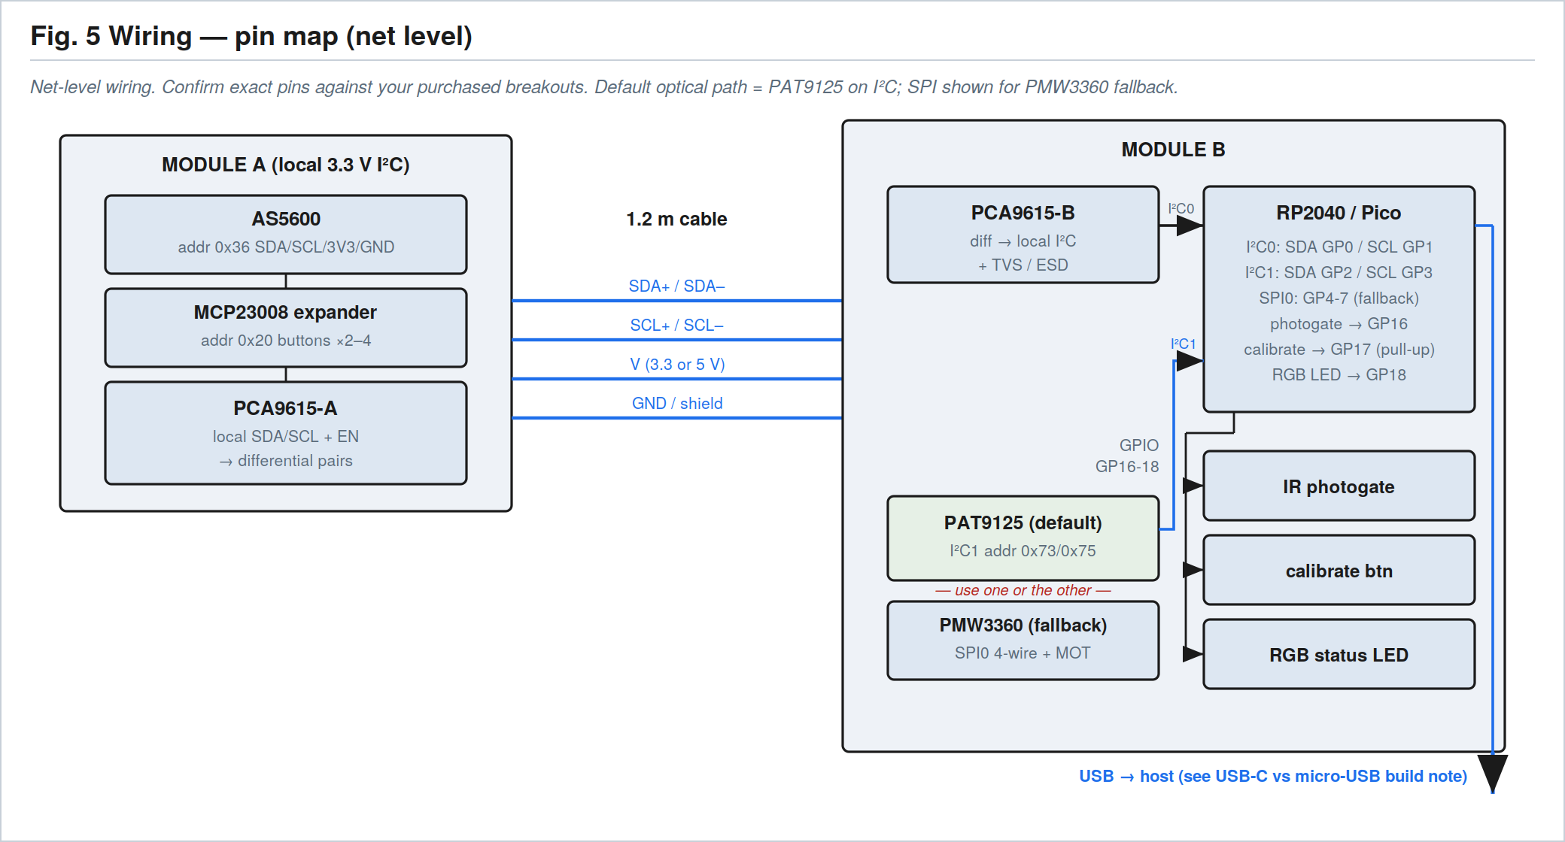
Fig. 5 — Net-level wiring. Confirm exact pins against the breakouts actually purchased.

6.1 Module A local I²C segment
Device | Address / signals | Connects to
AS5600 | 0x36 · SDA/SCL/3V3/GND | Local I²C → PCA9615-A
MCP23008 expander | 0x20 · buttons ×2–4 | Local I²C → PCA9615-A
PCA9615-A | local SDA/SCL + EN | Differential pairs → cable

6.2 Cable map
As in §5: SDA± (pair 1), SCL± (pair 2), V, GND/shield — PCA9615-A ↔ PCA9615-B.

6.3 RP2040 pin assignment (baseline)
Pin | Function | Notes
GP0 / GP1 | I²C0 SDA / SCL | Lever segment via PCA9615-B (AS5600 + buttons)
GP2 / GP3 | I²C1 SDA / SCL | PAT9125 optical sensor (default path)
GP4–GP7 | SPI0 | PMW3360 fallback only (MISO/MOSI/SCK/CS) + MOT
GP16 | Photogate input | Tip-passage / zero
GP17 | Calibrate button | Pull-up; local zero/calibration mode
GP18 | RGB status LED | WS2812 or common-cathode RGB + resistors
USB | Host link | HID gamepad + CDC serial (connector per §11)

PAT9125 and PMW3360 are alternatives — populate one. Keep I²C pull-ups on the local segments; fit TVS/ESD on the cable lines.

7. Consolidated bill of materials

7.1 Printed parts
Part | Material | Infill | Notes
Clamp jaws (upper/lower) | PETG/ASA | 40% | Scope-parametric; TPU pads
Follower arm + magnet hub | PETG/ASA | 100% | High-load; print flat
Roller carrier / shoe | POM or PETG+TPU | 100% | Low friction
AS5600 bracket | PETG/ASA | 40% | Airgap shim feature
Module A bay + cover, button caps | PETG/TPU | 30–40% | Strain-relief saddle
Clamshell upper/lower | PETG/ASA | 40% | Channel, bay, flange
V-groove insert(s) | PETG/ASA or POM/PTFE | 60–100% | Per cord family
Wiper cassette + compliant cap | PETG + TPU | 40% | Replaceable ring
Optical sub-bracket | PETG/ASA | 60% | Sets standoff
Flange / adapter + desk stand + bezel | PETG/ASA | 30–40% | Zero-plane hard stop

7.2 Hardware and fasteners
Item | Qty | Specification | Example source
Heat-set inserts M3 / M2 | ~12 / ~10 | Brass; ~4.0 / ~3.2 mm holes | CNC Kitchen, McMaster
Thumb screws M3 | 2 | M3×16 and M3×12 knurled | McMaster, Amazon
Shoulder screw | 1 | M3, Ø3.0×12 shoulder | McMaster
Machine screws M3 / M2 | ~8 / ~8 | M3×8–12; M2×6–8 | Generic
Dowel pins Ø3.0 | 4 | Steel ×10 | Generic
Diametric magnet | 1 | Ø6×2.5 | K&J Magnetics, DigiKey
Torsion spring | 1 | ~0.4 mm wire, light | Century Spring / generic
Roller bearing (option) | 1 | Ø6 OD × Ø2.5 ID | Generic
TPU/silicone pads + shoe | set | 2 mm 70A pads; 40–60A shoe | Printed or sheet stock
JST-GH 6-pin + contacts | 2 sets | 1.25 mm pitch locking | JST / DigiKey
Cable | 1 | 1.2 m, 2 twisted pairs + power + shield | Generic shielded

7.3 Electronic modules
Module | Qty | Interface | Example source
RP2040 / Raspberry Pi Pico (H) | 1 | USB / I²C / SPI | Raspberry Pi (already on hand)
AS5600 breakout | 1 | I²C | DFRobot / Seeed / generic
MCP23008 / PCF8574 expander | 1 | I²C | Adafruit / generic
PCA9615 differential I²C breakout | 2 | I²C diff | SparkFun / generic
PAT9125 optical board (default) | 1 | I²C | PixArt PAT9125EL-TKIT; meerstern board
PMW3360 optical board (fallback) | 1 | SPI | Tindie / Lectronz / Keycapsss
IR slotted photo-interrupter | 1 | GPIO | Omron / generic
RGB LED + calibrate button | 1 ea | GPIO | Generic
USB connector / breakout | 1 | USB | Per §11 decision
EEPROM (optional) | 1 | I²C | Generic 24-series

Cost roll-up (from plan §14): ~$100–180 for an early prototype, dropping to ~$70–100 for a polished kit after PCB consolidation and print optimisation.

8. Print settings, materials, and tolerances

8.1 Materials
Part class | Material | Rationale
Structural housings, clamp, flange | PETG (ASA if heat/UV) | Tough, dimensionally stable, easy to print
High-load (follower arm, latches) | PETG/ASA at 100% | Resists pivot and clamp loads
Low-friction surfaces (insert face, shoe) | POM/PTFE or polished resin | Minimises added insertion force
Compliant pads, cap shoe | TPU (40–70A) | Grip, gentle cord seating, scope protection

8.2 Print settings
Setting | Value / guidance
Layer height | 0.20 mm general; 0.12 mm for the V-groove insert, optical aperture, and magnet hub
Perimeters / walls | 3 (4 on the insert and clamp)
Infill | 40% general; 100% on follower arm, latches, small high-load parts; 60–100% on insert
Orientation – V-groove rails | Polished face up / aligned along the cord to minimise layer lines across the tracking surface
Orientation – clamp jaws | So clamping load is in-plane (avoid layer delamination across the grip)
Orientation – follower arm | Flat, long axis in-plane for bending strength
Heat-set insert holes | M3 ~4.0 mm, M2 ~3.2 mm — verify against your insert brand

8.3 Tolerances and fits
Feature | Nominal | Tolerance | Fit / type
Cord-channel centerline → sensor reference | set by design | ±0.1 mm | Critical
V-groove apex symmetry | on centerline | ±0.1 mm | Critical
Magnet airgap to AS5600 | 1.5 mm | ±0.5 mm | Set by bracket + shim
Magnet/chip concentricity | coaxial | ±0.2 mm | Critical
Photogate beam plane | gate plane | ±0.3 mm | Functional
Flange zero plane (hard stop) | datum | ±0.1 mm | Calibration reference
Magnet pocket (press-fit) | Ø6.0 | −0.05 mm | Press
Dowel/pivot bores | Ø3.0 | +0.05/+0.10 | Slip
General clearance holes | as drawn | +0.2 mm | Clearance

Print a fit-coupon and tune hole/pocket compensation to your printer before committing the insert and clamp parts.

9. Assembly sequence
- Install all heat-set inserts (clamp jaws, Module A bay, AS5600 bracket; Module B body, flange, sub-bracket, PCB bosses) with a soldering iron and insert tip.
- Module A: press the Ø6×2.5 magnet into the hub; mount the AS5600 breakout and set the 1.5 mm airgap with shims; fit the follower arm on the shoulder screw with the torsion spring; fit the roller/shoe; mount PCA9615-A + expander in the bay; crimp the JST-GH; route the cable through the strain-relief saddle; fit the TPU jaw pads.
- Module B: mount the Pico, PCA9615-B, optical sensor (in its sub-bracket at the chosen standoff), photogate, calibrate button, RGB LED, and USB connector in the lower shell; fit the V-groove insert and wiper cassettes; fit the compliant cap + shoe to the upper shell; install dowels and latch; attach the flange and desk stand.
- Connect the cable Module A ↔ Module B; connect USB to the host.
- Flash the firmware UF2; run calibration — pure 100 mm insertion (ruler jig), pure 360° roll (rotary jig), combined helical motion (cross-coupling check), and a lubricated-cord repeat after a wiper pass.

10. Build these de-risking jigs first
Per plan §16, prove the physics on a bench jig before printing a full enclosure.
- Fit-coupon: a small print of just the cord channel + V-groove + optical aperture, to validate standoff, slot, and fit on the real cord.
- Wiper test cord: run dry, silicone-lubricated, and phantom-residue conditions against candidate felt/foam rings while logging SQUAL.
- Linear depth jig: 300 mm ruler/linear stage for depth accuracy and drift.
- Rotary roll jig: 360°/720° fixture for roll error and wrap behaviour.
- Validation spreadsheet: set it up before testing so failures become design data, not anecdotes.

11. Open build decisions
Resolve these before or at build. The most consequential is the USB connector, because the Raspberry Pi Pico exposes micro-USB while the plan specifies USB-C.
Decision | Options | Recommendation | Resolve when
USB connector | (a) USB-C RP2040 board; (b) keep Pico H micro-USB; (c) USB-C breakout wired to Pico test pads | (a) for the USB-C spec, or (b) to use the Pico H on hand | Before printing the bezel
Optical sensor | PAT9125 (I²C, lensless) vs PMW3360 (SPI, lens) | PAT9125 first; switch only if Phase 0 SQUAL/accuracy fails | Phase 0 gate
V-groove angle | 90° vs 120° | Test both on the fit-coupon | Phase 0
Clamshell / clamp closure | Captive thumb screw vs over-center latch | Thumb screw baseline; latch if faster service wanted | At build
Insert surface | PETG/ASA vs POM/PTFE/resin | PETG first; swap if added force > 0.5 N | Phase 0 friction test

12. Builder hand-off checklist

Provide to the builder
- This blueprint (v4-FAB) plus the measured scope datums from §2.
- STL/STEP files for all printed parts (repo /hardware/stl and /cad).
- PCB files or the listed breakout boards, and the BOM in §7.
- Firmware UF2 (or repo link) and the calibration guide.

Returned by the builder
- Two assembled, cabled modules + desk stand, enumerating as one USB gamepad.
- Fit-coupon and jig results (depth, roll, friction, lubricated SQUAL) against the Phase 0 exit criteria.
- Photos and notes on any deviations from baseline dimensions.

Phase 0 exit criteria (from plan §11): depth ≤ ±5 mm over 300 mm; roll ≤ ±10–15°; dropout < 1%; lubrication passes after the wiper; stable lever signal over a 30-min moving-cable test with no bus lockups.

